Eleanor Jenner

Professor Xu

CMPSC 363

(Originally created spring 2015)

Project Description

The purpose of this project is to keep track of buildings that have apartments for rent, as well as the people and types of rooms in each separate apartment. This could be used to keep track of various buildings owned by the same person, so that they could manage each one; it could also be used to keep an entry for apartment searchers, as it keeps track of which apartments are empty and who is the landlord for each building.

On the next page I have the Entity/Relationship diagram for the database can be found, where it details each object and what it contains.

Apartment Database

Budget Contribution

Lives In

Landlord

Name

Tenant-Of

Room-In

Features

Type of

Room

Part of

Price

Sub - Address

Apartment

Price of

Utilities

Community

Features

Address

Room

Person

Building

E/R Description

* Building Entity
  + Most important entity
    - All other parts are work off of this in some way
  + Is both the core of the database itself and a present entity
    - Is an entity to show of unique attributes of a building
    - Also because a city will generally contain several different apartment buildings it may be nice to have the features to expand the database
  + Attributes:
    - Address (key)
    - Community features (such as a mail room or a shared laundry room)
    - Price of utilities (remains constant rate for all apartments)
* Apartment Entity
  + Only part that directly links to the Building entity
    - That is a many to one relationship, as a building may have many apartments, but an apartment is part of only one building.
    - Also, like most parts of this database, it is a weak entity set in relation to Apartment.
  + Has the attributes:
    - Price
    - Address (inherited from Apartment)
    - Sub-Address (key)
* Person Entity
* Describes someone living in the apartment
* Is in a one to one relationship with room
  + This is the room they sleep in (assuming no two people live in the same room), there is only one person per room and a single person does not live in more than one room. Typically a bedroom, but can totally be other types of rooms.
* Also in a many to one relationship with Apartment
  + Is a weak entity, that inherits from both Apartment and Building. Many people typically only live in one apartment.
* Attributes:
  + Name
  + Landlord (Boolean) (Assumes that one of the people who live in the building is the landlord)
  + Budget contribution (null if Landlord = true)
  + Address (inherited from Building)
  + Sub-Address (inherited from Apartment)
* Room Entity
  + Describes the various rooms in an apartment
  + Is in a many to one relationship with Apartment
    - As there may be many rooms in an apartment, but all rooms belong to only one apartment
  + Has the attributes:
    - Type of room
    - Features (such as closets or including various devices)

Relation Schema (Part 2)

* List of Relations:
  + Apartment to Building [A -> B], Room to Apartment [R -> A], Person to Apartment [P -> A], Person to Room [P -> R], Room to Person [R -> P], where Building = B, Apartment = A, Room = Room, and Person = P.
* Schema:
  + Building(Address, Community Features, Price of Utilities)
  + Apartment(Building Address, Sub-address, price)
  + Room(Type of Room, Features)
  + Person(Name, Building Address, Apartment Sub-Address, Landlord, Budget Contribution)
  + Part-of(Address, Sub-Address)
  + Room-of(Address, Sub-Address)
  + Lives-in(Address, Sub-Address)
  + Tenet-of(Address, Sub-Address)
* List of Keys:
  + Building (specifically attribute address)
    - Actual keys of the database: {B}.
* List of FDs:
  + B -> A
  + A -> R
  + A -> P

SQL Table Generation and Sample Tuples

-- phpMyAdmin SQL Dump

-- version 4.2.11

-- http://www.phpmyadmin.net

-- Host: 127.0.0.1

Generation Time: Apr 29, 2015 at 04:06 PM

-- Server version: 5.6.21

PHP Version: 5.6.3

SET SQL_MODE = "NO_AUTO_VALUE_ON_ZERO";

SET time_zone = "+00:00";

/*!40101 SET @OLD_CHARACTER_SET_CLIENT=@@CHARACTER_SET_CLIENT */;

/*!40101 SET @OLD_CHARACTER_SET_RESULTS=@@CHARACTER_SET_RESULTS */;

/*!40101 SET @OLD_COLLATION_CONNECTION=@@COLLATION_CONNECTION */;

/*!40101 SET NAMES utf8 */;

--

-- Database: `apartments`

-- --------------------------------------------------------

Table structure for table `apartment`

--

CREATE TABLE IF NOT EXISTS `apartment`

(

`sub_address` varchar(10) NOT NULL,

`address` varchar(200) NOT NULL,

`price` int(11) NOT NULL,

`number_of_rooms` int(11) NOT NULL

)

ENGINE=InnoDB DEFAULT CHARSET=utf8;

--

-- Dumping data for table `apartment`

--

INSERT INTO `apartment` (`sub_address`, `address`, `price`, `number_of_rooms`) VALUES

('#1', '102 Clinton Street, Campbell, CA 95008', 1800, 4),

('#2', '102 Clinton Street, Campbell, CA 95008', 2200, 5),

('#221', '864 Wood Street, Kernersville, NC 27284', 2500, 4),

('#222', '864 Wood Street, Kernersville, NC 27284', 2500, 4),

('#3', '102 Clinton Street, Campbell, CA 95008', 1600, 4),

('01', '210 Church Street South, Saint Louis, MO 63109', 1400, 4),

('03', '210 Church Street South, Saint Louis, MO 63109', 1300, 3),

('11', '879 Elmwood Avenue, Sevierville, TN 37876', 1700, 3),

('12', '879 Elmwood Avenue, Sevierville, TN 37876', 2100, 5),

('14', '879 Elmwood Avenue, Sevierville, TN 37876', 2000, 4),

('Unit 1', '1000 Aspen Court, Mount Laurel, NJ 08054', 2400, 5);

-- --------------------------------------------------------

-- Table structure for table `building`

--

CREATE TABLE IF NOT EXISTS `building`

(

`address` varchar(200) NOT NULL,

`community_features` varchar(45) DEFAULT NULL,

`price_of_utilities` int(11) NOT NULL

)

ENGINE=InnoDB DEFAULT CHARSET=utf8;

--

-- Dumping data for table `building`

--

INSERT INTO `building` (`address`, `community_features`, `price_of_utilities`) VALUES

('1000 Aspen Court, Mount Laurel, NJ 08054', 'Balcony, Yard', 200),

('102 Clinton Street, Campbell, CA 95008', 'Parking, In Unit Laundry', 200),

('210 Church Street South, Saint Louis, MO 63109', 'In Community Laundry', 160),

('377 Glenwood Avenue, Kernersville, NC 27284', 'Parking', 170),

('489 Ivy Court, Champlin, MN 55316', 'Parking', 120),

('600 Rose Lane, Semil, KN, 32100', 'NULL', 200),

('789 Cambridge Road, Ames, IA 50010', 'In Unit Laundry', 200),

('790 Walnut Street, Fort Washington, MD 20744', 'Balcony', 132),

('864 Wood Street, Kernersville, NC 27284', 'Pool, Fitness Center', 230),

('879 Elmwood Avenue, Sevierville, TN 37876', 'Balcony, In Community Laundry', 190),

('996 Aspen Court, The Villages, FL 32162', 'Beachside', 144);

-- --------------------------------------------------------

-- Table structure for table `rooms`

--

CREATE TABLE IF NOT EXISTS `rooms`

(

`type` varchar(45) NOT NULL,

`features` varchar(45) DEFAULT NULL,

`tenant_name` varchar(50)

DEFAULT NULL,

`address` varchar(200) NOT NULL,

`sub_address` varchar(10) NOT NULL

)

ENGINE=InnoDB DEFAULT CHARSET=utf8;

-- Dumping data for table `rooms`

--

INSERT INTO `rooms` (`type`, `features`, `tenant_name`, `address`, `sub_address`) VALUES

('Bedroom', 'Bed', 'Heinrich Kohler', '102 Clinton Street, Campbell, CA 95008', '#3'),

('Living Room', NULL, NULL, '102 Clinton Street, Campbell, CA 95008', '#3'),

('Kitchen', 'Gas Stove, Oven, Wood Countertops', NULL, '102 Clinton Street, Campbell, CA 95008', '#3'),

('Bathroom', 'Bathtub', NULL, '102 Clinton Street, Campbell, CA 95008', '#3'),

('Bedroom', 'Bed, Computer', 'Sarah Spears', '879 Elmwood Avenue, Sevierville, TN 37876', '12'),

('Bedroom', 'Bed, Computer, Walk-in Closet', 'Elizabeth Yerca', '879 Elmwood Avenue, Sevierville, TN 37876', '12'),

('Living Room', 'Television ', NULL, '879 Elmwood Avenue, Sevierville, TN 37876', '12'),

('Bathroom', 'Bathtub, Shower', NULL, '879 Elmwood Avenue, Sevierville, TN 37876', '12'),

('Bedroom', 'Bed', 'Alexander De Sauveterre', '102 Clinton Street, Campbell, CA 95008', '#1'),

('Kitchen', 'Granite Countertops, Oven, Electric Stove', '', '879 Elmwood Avenue, Sevierville, TN 37876', '12');

--

-- Table structure for table `tenant`

--

CREATE TABLE IF NOT EXISTS `tenant`

(

`name` varchar(50) NOT NULL,

`landlord` varchar(5) NOT NULL,

`budget_contribution` int(11) DEFAULT NULL,

`address` varchar(200) NOT NULL,

`sub_address` varchar(10) NOT NULL

)

ENGINE=InnoDB DEFAULT CHARSET=utf8;

--

-- Dumping data for table `tenant`

--

INSERT INTO `tenant` (`name`, `landlord`, `budget_contribution`, `address`, `sub_address`) VALUES

('Agatha Curtis', 'FALSE', 1500, '102 Clinton Street, Campbell, CA 95008', '#1'),

('Alexander De Sauveterre', 'FALSE', 300, '102 Clinton Street, Campbell, CA 95008', '#1'),

('Anna Ware', 'FALSE', 2500, '864 Wood Street, Kernersville, NC 27284', '#221'),

('Elizabeth Yerca ', 'FALSE', 1050, '879 Elmwood Avenue, Sevierville, TN 37876', '12'),

('Heinrich Kohler', 'TRUE', 0, '102 Clinton Street, Campbell, CA 95008', '#3'),

('Kealey Clinton ', 'FALSE', 1300, '864 Wood Street, Kernersville, NC 27284', '#222'),

('Nelson West', 'FALSE', 1200, '864 Wood Street, Kernersville, NC 27284', '#222'),

('Sarah Spears ', 'FALSE', 1050, '879 Elmwood Avenue, Sevierville, TN 37876', '12'),

('Slade Westley ', 'FALSE', 2400, '1000 Aspen Court, Mount Laurel, NJ 08054', 'Unit 1'),

('Sophia St. Pierre ', 'FALSE', 0, '102 Clinton Street, Campbell, CA 95008', '#1');

--

-- Indexes for dumped tables

--

Indexes for table `apartment`

--

ALTER TABLE `apartment`

ADD PRIMARY KEY (`sub_address`),

ADD UNIQUE KEY `Sub_Address_UNIQUE` (`sub_address`),

ADD KEY `Address_idx` (`address`);

--

-- Indexes for table `building`

--

ALTER TABLE `building`

ADD PRIMARY KEY (`address`),

ADD UNIQUE KEY `Address_UNIQUE` (`address`);

--

-- Indexes for table `rooms`

--

ALTER TABLE `rooms`

ADD KEY `fk_Rooms_Tenant1_idx` (`tenant_name`),

ADD KEY `Room_Address_idx` (`address`,`sub_address`);

--

-- Indexes for table `tenant`

--

ALTER TABLE `tenant`

ADD PRIMARY KEY (`name`),

ADD KEY `Sub_Address_idx` (`address`,`sub_address`);

--

-- Constraints for dumped tables

--

Constraints for table `apartment`

--

ALTER TABLE `apartment`

ADD CONSTRAINT

`Apartment_Address` FOREIGN KEY (`address`) REFERENCES `building` (`Address`)

ON DELETE NO ACTION ON UPDATE NO ACTION;

--

-- Constraints for table `rooms`

--

ALTER TABLE `rooms`

ADD CONSTRAINT

`Room_Address` FOREIGN KEY (`address`, `sub_address`) REFERENCES `apartment` (`Address`, `Sub_Address`)

ON DELETE NO ACTION ON UPDATE NO ACTION;

--

-- Constraints for table `tenant`

--

ALTER TABLE `tenant`

ADD CONSTRAINT

`Tenant_Address` FOREIGN KEY (`address`, `sub_address`) REFERENCES `apartment` (`Address`, `Sub_Address`)

ON DELETE NO ACTION ON UPDATE NO ACTION;

/*!40101 SET CHARACTER_SET_CLIENT=@OLD_CHARACTER_SET_CLIENT */;

/*!40101 SET CHARACTER_SET_RESULTS=@OLD_CHARACTER_SET_RESULTS */;

/*!40101 SET COLLATION_CONNECTION=@OLD_COLLATION_CONNECTION */;

Database Screenshots

Apartment:

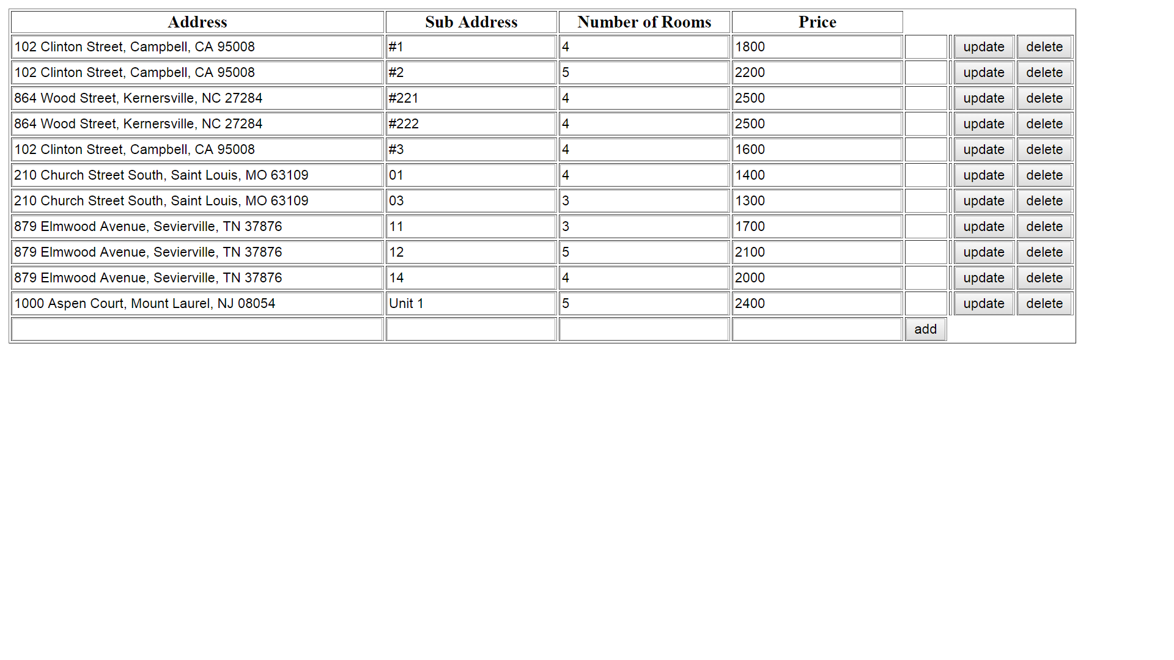

Building:

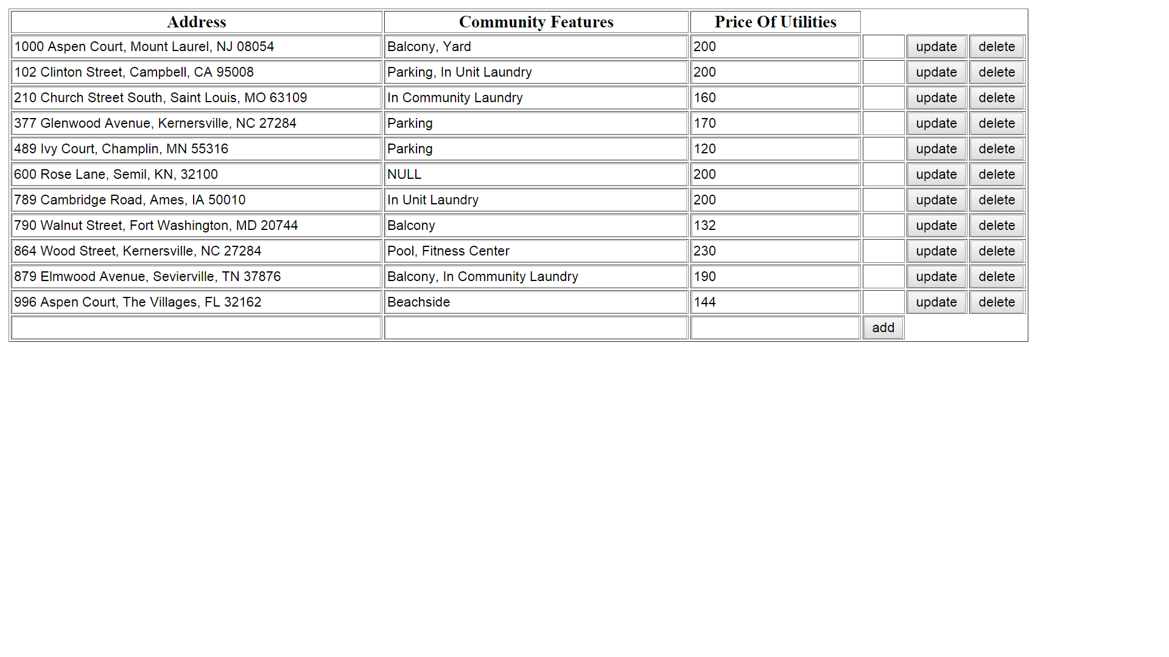

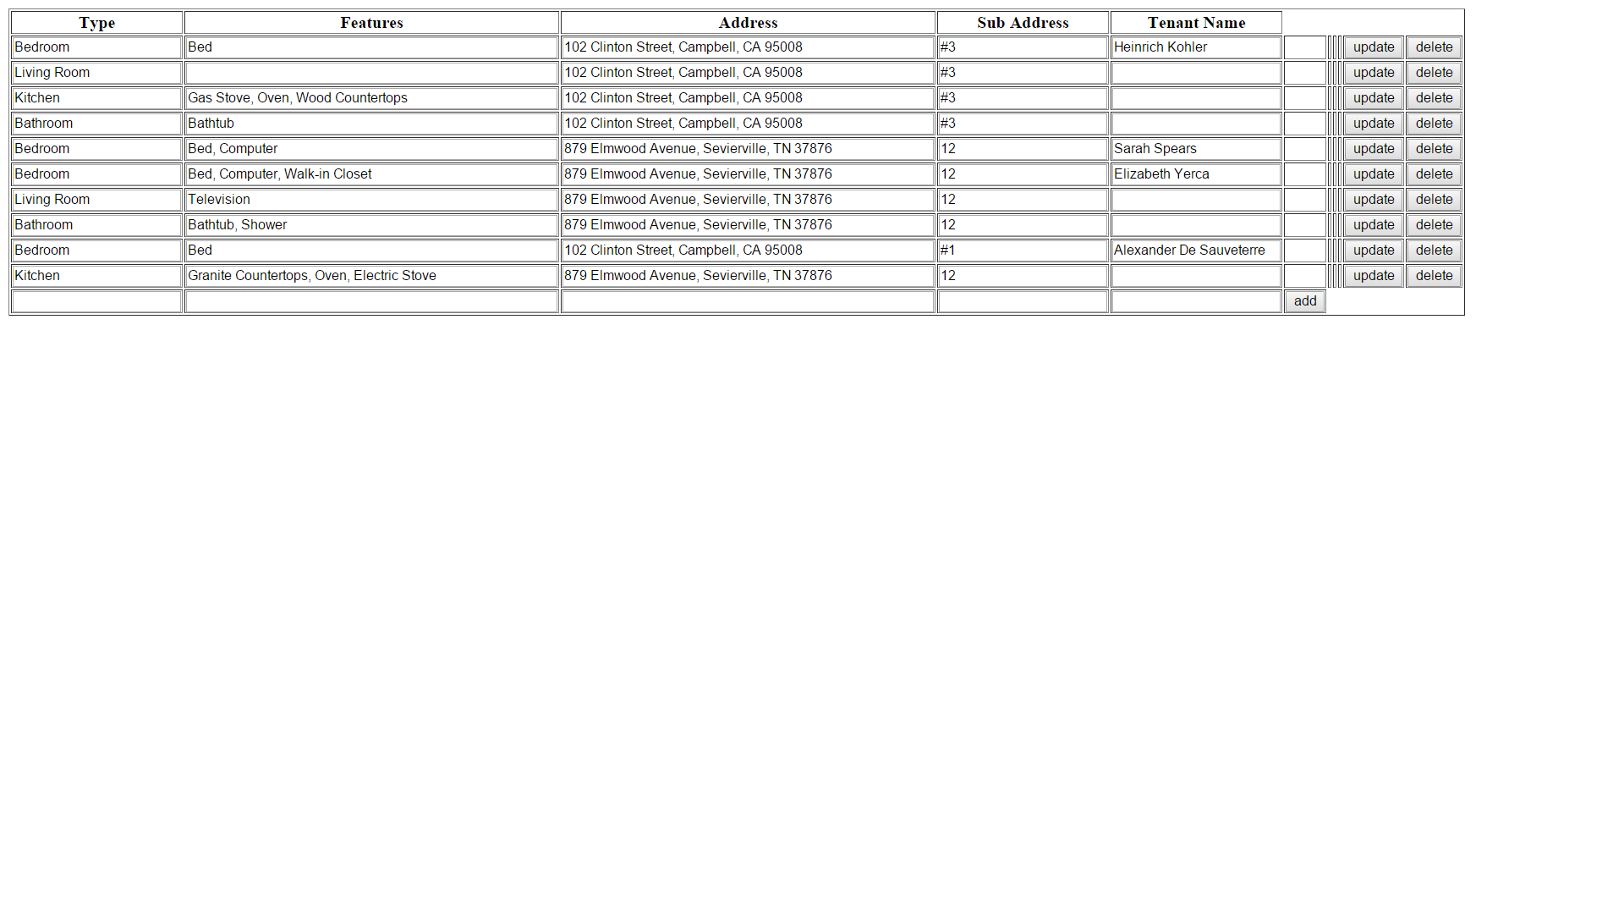Room:

Tenant:

